**PROJECT REPORT**

**FREELANCING WEBSITE**

Submitted in partial fulfilment of requirement of the Degree of

**BACHELOR OF TECHNOLOGY in COMPUTER SCIENCE & ENGINEERING**

BY

**Jeetraj Soni EN19CS301156**

Under the Guidance of

**Prof. Hemlata Patel**



**Department of Computer Science & Engineering Faculty of Engineering**

**MEDI-CAPS UNIVERSITY, INDORE- 453331**

**INDEX**

|  |  |  |
| --- | --- | --- |
| **S No.** | **Title** | **Page** |
| **1** | **Front Page** | **i** |
| **2** | **Approval** | **Ii** |
| **3** | **Declaration** | **Iii** |
| **4** | **Acknowledgement** | **Iv** |
| **5** | **Certificate** | **v** |
| **6** | **Table of content** | **Vi** |
| **7** | **Introduction** | **7** |
| **8** | **MERN Concept** | **9** |
| **9** | **Use cases of MERN** | **10** |
| **10** | **Top Brands using MERN technology** | **12** |
| **11** | **Features of MERN stack** | **15** |
| **12** | **Architecture of MERN stack** | **18** |
| **13** | **Advantages of MERN stack** | **20** |
| **14** | **MERN in mobile and app development** | **23** |
| **15** | **Introduction to Freelancing Website** | **27** |
| **16** | **Abstract** | **28** |
| **17** | **Objective** | **29** |
| **18** | **Scope** | **30** |
| **19** | **Modules** | **31** |
| **20** | **Features** | **32** |
| **21** | **Identification of need** | **33** |
| **22** | **System Analysis** | **34** |
| **23** | **Existing System** | **35** |
| **24** | **Proposed System** | **36** |
| **25** | **SRS** | **37** |
| **26** | **Feasiblity Study** | **38** |
| **27** | **Preliminary Product Design** | **39** |
| **28** | **Use Case diagram** | **40** |
| **29** | **Technical Requirement** | **41** |
| **30** | **Conclusion** | **42** |
| **31** | **Result** | **42** |

**Report Approval**

The Project Report entitled **“FREELANCING WEBSITE”** is hereby approved as a creditable study of an engineering subject carried out and presented in a manner satisfactory to warrant its acceptance as prerequisite for the Degree for which it has been submitted.

It is to be understood that by this approval the undersigned do not endorse or approved any statement made, opinion expressed, or conclusion drawn there in; but approve the “Project Report” only for the purpose for which it has been submitted.

Internal Examiner Name:

Designation

Affiliation

External Examiner Name:

Designation

Affiliation

**Declaration**

### I hereby declare that the Project entitled “FREELANCING WEBSITE” submitted in partial fulfilment for the award of the degree of Bachelor of Technology in ‘Computer Science & Engineering’ completed under the supervision of Prof. HEMLATA PATEL, Department of Computer Science, Medi-Caps University.

### Further, I declare that the content of this project, in full or in parts, have neither been taken from any other source nor have been submitted to any other Institute or University for the award of any degree or diploma.

_____________________

SIGNATURE

### Acknowledgements

I would like to express my deepest gratitude to Honourable Chancellor, **Shri R C Mittal,** who has provided me with every facility to successfully carry out this Industrial Training, and my profound indebtedness to **Prof. (Dr.) Dilip Kumar Patnaik,** Vice Chancellor, Medi-Caps University, whose unfailing support and enthusiasm has always boosted up my morale. I also thank **Dr. Suresh Jain,** Dean, Faculty of Engineering, Medi-Caps University, for giving me a chance to work on this Industrial Training. I would also like to thank my Head of the Department **Prof. (Dr.) Pramod S. Nair** for his continuous encouragement for betterment of the Industrial Training.

I express my heartfelt gratitude to my **Instructor and Guide prof. HEMLATA PATEL,** **Department of Computer Science, Medi-Caps University**, without whose continuous help and support, this project would ever have reached to the completion.

It is their help and support, due to which we became able to complete the design and technical report. Without their support this report would not have been possible.

Name: JEETRAJ SONI

E.No: EN19CS301156

B.Tech. IV Year

Department of Computer Science & Engineering

Faculty of Engineering

Medi-Caps University, Indore

**Certificate**

I/We, **Prof. Hemlata Patel** certify that the project entitled **“Freelancing System”** submittedin partial fulfilment for the award of the degree of Bachelor of Technology **Jeetraj Soni** istherecordcarried out by him/them under my/our guidance and that the work has not formed the basis of award of any other degree elsewhere.

________________________________

Prof. Hemlata Patel

Medi-Caps University, Indore

________________________________

External Examiner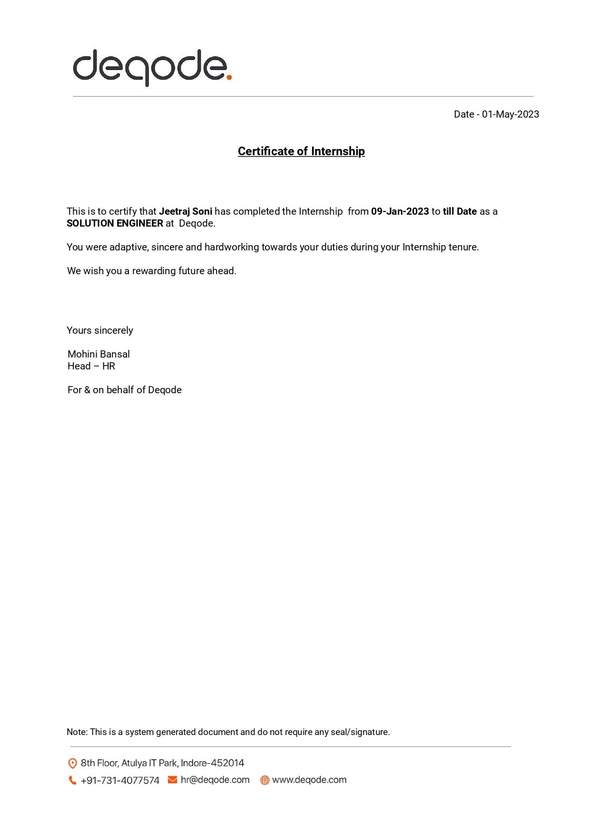

**Introduction to MERN Technology:**

MERN stands for MongoDB, Express, React, Node, after the four key technologies that make up the stack. Express and Node make up the middle (application) tier. Express.js is a server-side web framework, and Node.js is the popular and powerful JavaScript server platform. Regardless of which variant you choose, ME(RVA)N is the ideal approach to working with JavaScript and JSON, all the way through. The MERN architecture allows you to easily construct a three-tier architecture (front end, back end, database) entirely using JavaScript and JSON.

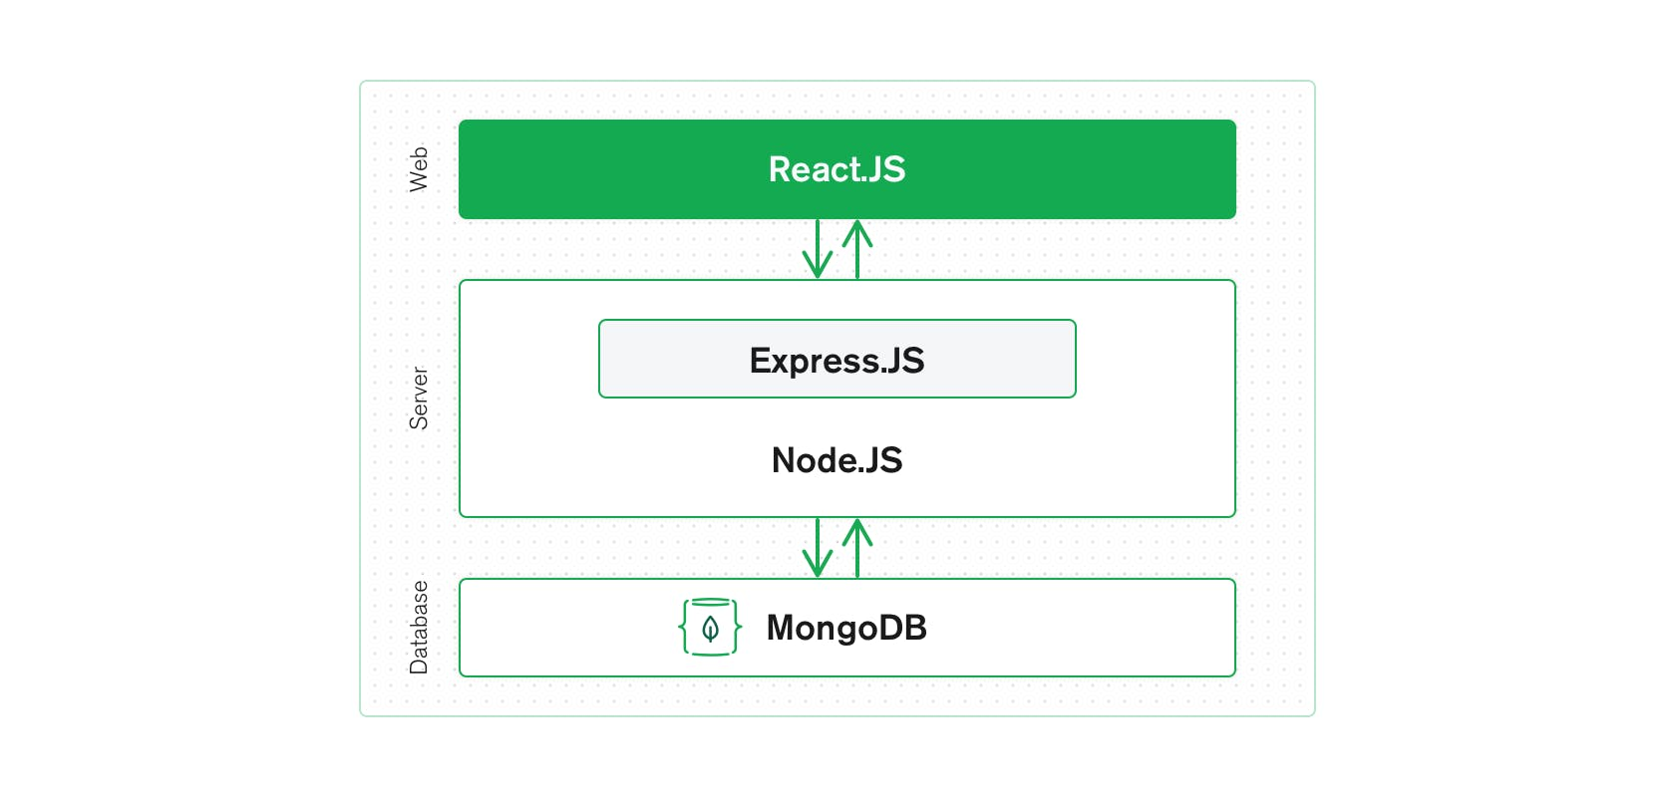

MERN is a full stack, following the traditional three-tier architectural pattern, including the front-end display tier (React.js), application tier (Express.js and Node.js), and database tier (MongoDB). Let’s start with MongoDB, the document database at the root of the MERN stack. MongoDB was designed to store JSON data natively (it technically uses a binary version of JSON called [BSON](https://www.mongodb.com/json-and-bson)), and everything from its command line interface to its query language (MQL, or MongoDB Query Language) is built on JSON and JavaScript.

MongoDB works extremely well with Node.js, and makes storing, manipulating, and representing JSON data at every tier of your application incredibly easy. For cloud-native applications, [MongoDB Atlas](https://www.mongodb.com/cloud/atlas) makes it even easier, by giving you an auto-scaling MongoDB cluster on the cloud provider of your choice, as easy as a few button clicks.

Express.js (running on Node.js) and React.js make the JavaScript/JSON application MERN full stack, well, full. Express.js is a server-side application framework that wraps HTTP requests and responses, and makes it easy to map URLs to server-side functions. React.js is a front end JavaScript framework for building interactive user interfaces in HTML, and communicating with a remote server.

The combination means that JSON data flows naturally from front to back, making it fast to build on and reasonably simple to debug. Plus, you only have to know one programming language, and the JSON document structure, to understand the whole system! MERN is the stack of choice for today’s web developers looking to move quickly, particularly for those with React.js experience.

**MERN concept:**

**React.js- front end-**

The top tier of the MERN stack is React.js, the declarative JavaScript framework for creating dynamic client-side applications in HTML. React lets you build up complex interfaces through simple components, connect them to data on your back-end server, and render them as HTML.

React’s strong suit is handling stateful, data-driven interfaces with minimal code and minimal pain, and it has all the bells and whistles you’d expect from a modern web framework: great support for forms, error handling, events, lists, and more.

The top tier of the MERN stack is mainly handled by React.js. It is one of the most prominent used open-source front-end JavaScript libraries used for building Web applications. It is famous for creating **dynamic client-side applications**. React will help you construct complex interfaces by using single components. It also connects those complex interfaces to data available on the backend server. React is used to create mobile applications (React Native) and web applications. React allows the reusability of code and can easily support it, which has many benefits and is much time saver. It permits users to create large web applications that can easily change the data of the page even without reloading the page.

**Express.js and Node.js server tier-**

The next level down is the Express.js server-side framework, running inside a Node.js server. Express.js bills itself as a “fast, unopinionated, minimalist web framework for Node.js,” and that is indeed exactly what it is. Express.js has powerful models for URL routing (matching an incoming URL with a server function), and handling HTTP requests and responses.

By making XML HTTP Requests (XHRs) or GETs or POSTs from your React.js front end, you can connect to Express.js functions that power your application. Those functions, in turn, use MongoDB’s Node.js drivers, either via callbacks or using promises, to access and update data in your MongoDB database.

It is just next level from the top layer and is mainly handled by two components of the MERN stack, i.e., **Express.js** and **Node.js.** These two's components handle it simultaneously because Express.js maintained the Server-side framework, running inside the Node.js server. Express.js is one of the widely used backend development JavaScript Frameworks. It allows developers to spin up robust APIs (Application Programming Interface) and web servers much easier and simpler. It also adds helpful functionalities to Node.js HTTP (**HyperText Transfer Protocol**) objects. Whereas on the other hand, Node.js plays a very important role in itself. It is an open-source server environment, and it is a cross-platform runtime environment for executing JavaScript code outside a browser. Node.js continuously uses JavaScript; thus, it's ultimately helpful for a computer user to quickly create any net service or any net or mobile application.

**MongoDB database tier-**

If your application stores any data (user profiles, content, comments, uploads, events, etc.), then you’re going to want a database that’s just as easy to work with as React, Express, and Node. That’s where MongoDB comes in: JSON documents created in your React.js front end can be sent to the Express.js server, where they can be processed and (assuming they’re valid) stored directly in MongoDB for later retrieval. Again, if you’re building in the cloud, you’ll want to look at Atlas. If you’re looking to set up your own MERN stack, read on!

It is one of the most important levels of the MERN Stack and is mainly handled by MongoDB; the main role of a database is to store all the data related to your application, for example - **content, statistics, information, user profiles, comments** and so on. It mainly stores all the data for **safety purposes**. It maintains a proper record, which usually returns the data to the user whenever required. It mainly stores the data in the database. It generates two or more replica files of the data so that whenever the system fails, it can retrieve the exact information or data that the user wanted earlier. It implies that MongoDB is not based on the table-like relational database structure. On the other hand, it provides an altogether different mechanism for the retrieval and storage of data. **Mongo DB** is the most popular NoSQL (NoSQL or Non Structured Query Language) database, an open-source document-oriented database. The term 'NoSQL' typically means a non-relational database that does not require a fixed schema or proper relational tables to store the necessary data in it. MongoDB stores the data in a different format other than the relational tables, consisting of rows and columns.

**Use cases of MERN:**

Like other popular web stacks, it is possible to develop whatever you want in MERN. Nonetheless, it is ideal for cloud-based projects where you require intensive JSON and dynamic web interfaces. A few examples of purposes where MERN is used are:

### Calendars and To-do Apps

A calendar or a to-do app is a rudimentary project that can tell you a lot about the mechanics of the MERN stack. You can design the frontend, i.e., the interface of the calendar or to-do app using ReactJS. The data to be stored, accessed, modified, shown in the to-do app is made possible using MongoDB.

**Interactive Forums**

Another suitable use case for MERN is an interactive forum, which can be a social media platform or a website that allows users to share messages and communicate. The topic of the interactive forum may or may not be predefined.

### Social Media Product

An interactive forum is just one use of the MERN stack for social media. These include ads, posts, a mini web app embedded in the social media page, etc.

**Top brands using MERN stack:**

**UberEats** – UberEats make use of React framework to renovate their restaurant dashboard to make it more appealing and engaging. Developers worked hard to improve the driver’s communication with food outlets. By implementing the demo app permit them to do so.

**Instagram** – Instagram also follows the same path as Facebook does and enjoys all the benefits of React functionalities. The developers implemented push notifications to React Native and planted a new option that allows users to save the posts that they found exciting. This framework also helps to execute the Post Promote feature easily. React Native helps you achieve faster startup time and more appealing UX.

**Walmart** – The experts here executed React Native mobile app to boost their hybrid app performance. With this, 95% of the mobile app codebase is shared between iOS and Android platforms.

## Netflix and Node.js: Netflix is the world’s leading provider of streaming media and video-on-demand. It’s a data-driven platform that uses a massive amount of A/B testing to build rich experience for its 93 million subscribers worldwide. Great numbers of unique packages every push cycle create a problem of conditional dependencies and app scalability. That’s why the company decided to [leverage the lightweight and fast Node.js](https://www.netguru.com/blog/nodejs-performance-web-application-benefit). One of the most important results of this was a 70-percent reduction in start-up time.

## Trello and Node.js: Trello is a project management app that we embrace in our daily work at Netguru. The server side of Trello was built in Node.js. An event-driven, non-blocking server was a good solution for an instant propagation of updates, which required holding a lot of open connections. Node.js also became useful when the company was prototyping a tool for a single-page app. It was a quick way for them to get started and make sure that everything was going in the right direction.

## PayPal and Node.js: PayPal, a worldwide online payments system, has also moved their backend development from [Java to JavaScript and Node.js](https://www.netguru.com/blog/node-js-vs-java). Beforehand, the engineering teams at the company were divided into those who code for the browser and those who code for the application layer, and it didn’t work perfectly. Then, full-stack engineers came to the rescue, but that model wasn’t ideal too. Adopting Node.js solved their problems, as it allowed for writing the browser and the server applications in the same programming language – JavaScript. As a result, the unified team is able to understand problems at both ends and react more effectively to the customer needs.

## LinkedIn and Node.js: LinkedIn, the world’s biggest business and employment-oriented social networking service, also trusted Node.js, and last year they moved their mobile app backend from [Ruby on Rails to Node.js](https://www.netguru.com/blog/ruby-on-rails-vs-node-js). Even though at that time it was still a very immature environment, it proved to be a smart move for the company. The new app is two to ten times faster than its predecessor, and it is also extremely lightweight. On top of that, the development was quite quick.

## Walmart and Node.js: Walmart is the world’s largest retailer, and it is now making headway into the online retail market. The giant has jumped on the bandwagon of working with Node.js – a relatively new and very trendy technology despite the risk that was involved in such a move. The company re-engineered the mobile app to provide sophisticated features on the client side. Walmart especially appreciated the Node.js’ famous asynchronous I/O and its single-threaded event loop models that can efficiently handle concurrent requests.

## Uber and Node.js: Uber, a platform that connects drivers with customers in need of transportation (and now also food delivery) services, leverage many tools and programming languages in the engineering of their app. Uber’s tech stack is constantly evolving, and they’ve since introduced new technologies that proved more efficient in certain areas. That said, Node.js is still one of the crucial cogs in the company’s operation, as it enables scaling up in line with the steadily rising demand for their services.

## Medium and Node.js: Medium is an online publishing platform that uses Node.js for their web servers. Even though at first glance the web app might seem like a simple HTML page, there is much more technology behind it. Medium is a data-driven platform that evolves together with the users and their behaviour. Node.js is particularly useful when it comes to running A/B tests to get a better comprehension of product changes and experiment with new ideas.

## Groupon and Node.js: Groupon, a popular online deal marketplace operating in many countries worldwide, decided to rebuild their entire web layer on top of Node.js. The initial motivation was the fact that [the stack they had been using earlier became hard to maintain](https://www.netguru.com/blog/challenges-with-node.js-application-maintenance). Especially when as a result of their numerous acquisitions they ended up with a bunch of other stacks to manage in different parts of the world. These events led the company to unify the development across all their platforms. In a year-long project, they moved to Node.js, making it one of the largest production deployments of Node.js worldwide.

## Ebay and Node.js: eBay, a multinational e-commerce company, has always been open to new technologies. The company settled on Node.js for two prime reasons: they needed an application as real-time as possible to maintain live connections with the server and a solution that could orchestrate a huge number of eBay-specific services that display information on the page. Node.js seemed to be a perfect fit.

## NASA and Node.js: Yes, that’s right. NASA use Node.js too. The technology is of much greater importance than in other applications because it saves lives, keeping astronauts safe during their dangerous space expeditions. After an accident in which one of the astronauts nearly died because of the ineffective data hosted in many locations, NASA faced the challenge of moving the data related to the EVA spacesuits to one cloud database in order to reduce the access times. The new system based on Node.js decreased the number of steps in the process from 28 to 7.

## Home Made and Node.js: Home Made is a hybrid letting agency that brings the quality of service of a top-notch traditional estate agency for a low flat fee. The company focuses on £500,000+ residential properties in London. The system has big, complex databases with a significant number of records. As the founders set app performance as one of the major priorities, the [Node.js development team](https://www.netguru.com/services/node-js-development) recommended Node.js as the backend solution. The platform was adapted to serve more traffic, effectively handling multiple requests sent to the server while maintaining high performance and a smooth user experience.

## Yahoo and Node.js: The Yahoo frontend team has been using Node.js in production to serve web pages for a quite long time. A lot of their new products are Single-Page-Applications or content sites using Node.js. They’re pumping around 25,000 requests per second through the Node.js servers, which confirms that this Javascript framework scales and is very performant. Eric Ferraiuolo, Principal Software Engineer at Yahoo, reveals that every property they moved over to Node.js stack has seen increase in performance

**Features of MERN stack:**

* **Schema-less Database:** MongoDB has this one of the great features, which means that one collection can hold different types of documents in it. Due to this extraordinary feature, MongoDB provides great flexibility to databases. In the MongoDB database, a single collection comprises multiple documents, and these documents may further comprise the different numbers of values, fields, and so on. One document doesn't need to be a must to relate with the other documents, as it happens in relational databases.
* **Indexing:** In the MongoDB database, one can easily fetch out the necessary data from the data pool due to this indexing feature. In MongoDB, every data item has provided a particular index, categorized as primary and secondary indices. With this indexing, data retrieval is easier for the user; it saves a lot of time. If the data is not indexed, the database searches each document with the specified query, which takes lots of time and is inefficient.
* **Document Oriented:** In MongoDB, all the data has been stored in documents instead of tables like SQL. Also, these documents have their unique object id. In these documents, the informative data is stored in fields, i.e., **key-value** pairs instead of columns and rows, making the data much more flexible and easier to fetch out rather than applying queries for every data compared to RDBMS.
* **Faster -** MongoDB is very fast compared with relational database (**RDBMS**), which is document-oriented. Each data item has its index value, making it easier for us to retrieve any data without wasting time writing queries and making logic accordingly.
* **Scalability:** MongoDB is more scalable with the help of sharding. It provides horizontal scalability. Here the term sharding means distributing data on multiple servers; in this, a large amount of data has been divided into multiple small data chunks with the help of shard key. These types of **data chunks** are evenly distributed across shards that reside across many physical servers.
* **High Performance:** MongoDB has very high performance and has data persistency as compared to other databases due to the presence of its great features like **indexing, scalability, replication**, etc.
* **Replication and Highly Available -** MongoDB increases the availability of data due to creating multiple copies of data on different servers. Providing redundancy or data replication ultimately protects the database from any hardware failure and protects the data from being lost in the future. I suppose if one server was not working or clashes due to error, and then data can easily be retrieved from other active servers, who are currently working at that time, this will all be due to redundancy of data.
* **Aggregation:** This feature of MongoDB is quite similar to the SQL GROUPBY clause. This GROUPBY clause performs various operations on the grouped data to get the unique or computed
* **Simple Environment Setup -** MongoDB has a very simple environment setup. One can easily set up MongoDB in their system without applying much effort.
* Express makes Node.js web and mobile application development much easier and faster.
* Express has a very simple environment setup. One can easily set up Express in their system and configure it without applying much effort.
* Express is very easy to connect with Databases like MongoDB.
* Based on HTTP methods and URLs, Express allows you to define the routes of your application.
* Routing mainly aims to describe code that needs to be run in response to any request received by a server. Routing is generally done based on the sequence of URL patterns and the HTTP method, which is associated with the request.
* If you want to perform additional tasks and functions on any request and response, you can easily use various middleware modules present in Express.
* The request is a message that arrives at the server for requesting something, and a Response is a message sent by the server to a client in the form of the result of whatever the client asked for.
* If any error occurs and you want to handle it, you can easily handle it by using error handling middleware.
* **Middleware** is used somewhere during the lifecycle of request or response in the form of code. It is mainly used to add functionalities or augment the behaviour of the webserver.
* Express also facilitates you to create a **REST API** (Representational State Transfer Application Programming Interface)
* The REST APIs is also known as RESTful API, It mainly conforms to the constraints of REST architectural style, and it also allows for interaction with RESTful web services. The main advantage of REST API is that it provides great flexibility; it uses HTTP requests to access and use data.
* The data flow into a website structure can easily facilitate by using the two template engines, EJS and Jade, provided by Express.
* Express has a gigantic suite of third-party add-ons so that developers can use it to provide better functionality, helps to increase the security level, and improve speed.
* It is very efficient and scalable; one can easily access it from anywhere and use it simultaneously on different systems, and very fast.
* It is Single-threaded and Asynchronous.
* It also has the biggest community for Node.js.
* With its built-in router, it promotes code reusability.
* If we want to understand the architecture behind web servers and their working along with the organization, then learning Express is the best option.
* **Easy to learn -** One of the great advantages of using react as it is very easier for a beginner to learn it and make web and mobile applications using this front-end framework. Anyone with a piece of previous basic knowledge in programming can easily understand React compared to Angular. Angular is referred to as a ' Domain Specific Language ', so it is implied that it is quite difficult to understand it. For Learning React, you need the basic knowledge of CSS and HTML.
* **Simple -** React is one of the simplest open-source JavaScript front-end frameworks for building web and mobile applications. It uses the component-based approach, uses plain and simple JavaScript, and a well-defined lifecycle, which makes react much simpler and easier. So that one can easily learn it and build professional mobile and web applications. It uses a simple syntax named JSX, which allows learners or developers to mix HTML with JavaScript to make it easier for them to apply and use it for making efficient web and mobile applications. However, it is not required to use JSX, you can either use plain JavaScript, but as compared to JSX, JSX is the much better option over it due to its simplicity and easier syntax.
* **Data Binding -** React uses an application architecture known as Flux to control data flow to components via one control point called the dispatcher. It uses **one-way data binding**, which is easier to debug self-contained components of large React applications.
* **Native Approach -** React is used to create mobile applications (React Native) and web applications. React allows the reusability of code and can easily support it, which has many benefits and is much time saver. So simultaneously, at the same time, we can make **IOS, Web applications** and Android.
* **Performance -** React has very fast performance due to the immutability of data. As the name suggests, we can predict that the immutable data structures never change and allows you to compare direct object references instead of doing deep-tree comparisons. The above reason ultimately affects the performance of reacting and makes it faster.
* **Testability -** React is very easy to test; whatever applications we are generating from the react, whether mobile or web applications, it is much easier for us to test it on react. There are some state functions in the react, where various react views are treated as these functions of the states, and we can easily manipulate with the state we pass to the react view. Also, we can take a look at the output and triggered actions, functions, events, etc.
* **Easy Scalability:** js is highly scalable because it uses a single-threaded model with event looping. The server usually responds in a non-blocking way due to the help of the event mechanism. It also makes the server very scalable instead of traditional servers that create limited threads to handle requests. Node.js uses a single-threaded program, and this program will be able to provide service to many requests.
* **Fast:** The event loop in Node.js handles all asynchronous operations, so Node.js acts like a fast suite, and all the operations in Node.js are performed quickly like network connection, reading or writing in the database, or file system. It runs on the V8 engine developed by Google.
* **Easy to learn and debug code:** JS is quite easy to learn and debug because it uses JavaScript for running code of web-based projects and various web and mobile applications. If you have excelled in front-end developing and have a good command of JavaScript, you can easily build and run the application on Node.js and explore more as much you can; it depends on your capability.
* **Real-time web apps:** JS plays a key role in making real-time web applications. And If you are building a mobile or a web application, you can also use PHP, although it will take the same time duration as when you use Node.js. Still, if someone wants to build gaming apps and chat applications, then Node.js is a much better option because of its faster synchronization.
* **Caching Advantage:** JS provides the caching property in which a single module is cached. Sometimes you do not need to re-execute the same lines of code because it has already been cached using Node.js.
* **Data Streaming:** In Node.js, hypertext transfer protocol ( HTTP ) requests and responses area unit thought-about as 2 separate events. They're knowledge streams, thus once you method a file at the time of loading, it'll scale back the time and create it quicker once the info is given within the style of transmissions. It additionally permits you to stream audio and video files at lightning speed.
* **Object-Oriented Approach:** A huge complaint against Node.js was its JavaScript heritage, which frequently involved many procedural spaghetti codes. Frameworks like Coffee Script and Typescript solved these issues but came as a bolt-on for those who seriously cared about coding standards. With the release and general adoption of ES6, Classes are built into the framework, and the code looks syntactically similar to C#, Java and SWIFT.
* **Event-Driven** and **Asynchronization**- All APIs of the Node.js library area unit asynchronous, that is, non-blocking. It suggests that a Node.js based mostly server ne'er waits for associate API to come back knowledge. The server moves to the consequent API once line it, and a notification mechanism of Events of Node.js helps the server to urge a response from the previous API decision.
* **Corporate Support:** There are a lot of famous companies like PayPal, Wal-Mart, Microsoft, Google that are using Node.js for building the applications. Node.js uses JavaScript, so most companies are combining front-end and backend Teams into a single unit.

## Architectural Structure of MERN Stack:

MERN has a 3-tier Architecture system mainly consisting of 3 layers -

These layers are as follows:

1. Web as front-end tier
2. Server as the middle tier
3. Database as backend tier

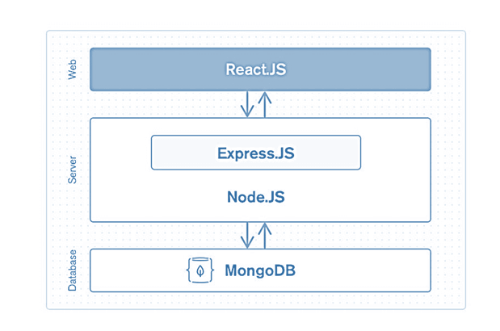

We already know that it comprises 4 components, i.e., **MongoDB, Express.js, React, Node.js.**

Now let us understand in more detail about these three tiers which are mentioned above -

1. **Web or front-end tier -** The top tier of the MERN stack is mainly handled by React.js. It is one of the most prominent used open-source front-end JavaScript libraries used for building Web applications. It is famous for creating **dynamic client-side applications**. React will help you construct complex interfaces by using single components. It also connects those complex interfaces to data available on the backend server. React is used to create mobile applications (React Native) and web applications. React allows the reusability of code and can easily support it, which has many benefits and is much time saver. It permits users to create large web applications that can easily change the data of the page even without reloading the page.
2. **Server or middle-tier -** It is just next level from the top layer and is mainly handled by two components of the MERN stack, i.e., **Express.js** and **Node.js.** These two's components handle it simultaneously because Express.js maintained the Server-side framework, running inside the Node.js server. Express.js is one of the widely used backend development JavaScript Frameworks. It allows developers to spin up robust APIs (Application Programming Interface) and web servers much easier and simpler. It also adds helpful functionalities to Node.js HTTP (**HyperText Transfer Protocol**) objects. Whereas on the other hand, Node.js plays a very important role in itself. It is an open-source server environment, and it is a cross-platform runtime environment for executing JavaScript code outside a browser. Node.js continuously uses JavaScript; thus, it's ultimately helpful for a computer user to quickly create any net service or any net or mobile application.  
   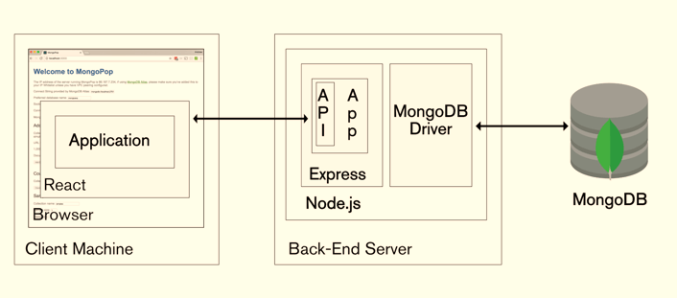
3. **Database as backend tier -** It is one of the most important levels of the MERN Stack and is mainly handled by MongoDB; the main role of a database is to store all the data related to your application, for example - **content, statistics, information, user profiles, comments** and so on. It mainly stores all the data for **safety purposes**. It maintains a proper record, which usually returns the data to the user whenever required. It mainly stores the data in the database. It generates two or more replica files of the data so that whenever the system fails, it can retrieve the exact information or data that the user wanted earlier. It implies that MongoDB is not based on the table-like relational database structure. On the other hand, it provides an altogether different mechanism for the retrieval and storage of data. **Mongo DB** is the most popular NoSQL (NoSQL or Non-Structured Query Language) database, an open-source document-oriented database. The term 'NoSQL' typically means a non-relational database that does not require a fixed schema or proper relational tables to store the necessary data in it. MongoDB stores the data in a different format other than the relational tables, consisting of rows and columns.

## Advantages of MERN Stack:

There are a lot of advantages of MERN Stack, some of them are mentioned below -

1. For a smooth development of any web application or mobile app, it supports MVC (**Model View Controller**) architecture; the main purpose of this architecture is to separate the presentation details with the business logic.
2. It covers all the web development stages starting from front-end development to backend development with JavaScript.
3. It is an open-source framework mainly used to develop web-based or mobile applications and is supported by the community.
4. It is very fast and efficient compared to MEAN Stack and mostly suitable for small applications, whereas MEAN Stack is suitable for developing large applications.

## Why should we choose MERN Stack for building Mobile and Web applications:

1. **Cost-effective:** All the four technologies that are mentioned above, MERN (MongoDB, Express.js, React.js, and Node.js) are used in MERN Stack is built on JavaScript that makes it cost-effective and within less cost investment user will able to get the better results or output.
2. **SEO friendly:** Here, **SEO** (**Search Engine Optimization**) friendly means that Google, Yahoo and other search engines can search each page on the website efficiently and easily, interpret and correlate the content effectively with the searched text and easily index it in their database. As whenever websites are created using MERN technologies, then it is always SEO friendly.
3. **Better performance:** Better performance refers to the faster response between backend and front-end and database, which ultimately improves the website speed and yields better performance, thus providing a smooth user experience.
4. **Improves Security:** It mainly concerns the security of applications generated using MERN; her web application security refers to various processes, methods or technologies used for protecting web servers and various web applications, such as APIs (**Application user interface**) from the attack by internet-based threats. Generally, secured hosting providers can easily integrate applications created using the MERN stack. For more or better security Mongo DB and Node.js security tools are also used.
5. **Provide the fastest delivery:** Any Web applications and mobile applications created by using MERN Stack are built much faster, which also helps to provide faster delivery to our clients.
6. **Provides faster Modifications:** MERN stack technologies supports quick modifications as per the client's request in the mobile and web applications.
7. **Open Source:** All the four technologies that are involved in MERN are open-source. This feature allows developers to get solutions to queries that may evolve from the open portals during development. As a result, it will be ultimately beneficial for a developer.
8. **Easy to switch between client and server:** MERN is very simple and fast because it is written in only one language. And also, it is very easy to switch between client and server.

**FREELANCING WEBSITE:**

**Introduction:**

**Who Is a Freelancer?**

A freelancer is a self-employed person who offers services, often working on several jobs for various clients at a time. Freelancers usually make money on a per-task basis, charging hourly or daily rates for their work. Freelance work is usually for the short-term. Becoming a freelancer is a fast and affordable way to start earning an income from home. Especially if you freelance a skill you already have, you can get started offering your services today.

# What is Freelancing?

Freelancing is a contract-based profession where you use your skills, education, and experience to work with multiple clients and take on various tasks. Freelancing usually involves jobs that allow you to work-from-home. It is just that many of the jobs that freelancers perform can be delivered over the internet without their presence at the company or client’s place. Freelance marketplaces provide a marketplace for freelancers and buyers. Service providers or sellers create a profile where they include details of the services they offer, a sample of their work, and in some cases information about their rates. Buyers register and complete basic profile, and then post projects as he/she required. Buyers will then bid for these projects on a fixed price or hourly basis. Many of these websites have user review sections that tell about the freelancer’s reputation who list there.

**Problem statement:**

### Low income because of firm’s high commission.

As mentioned earlier, they cut out a commission, including tips from your earnings for using their platforms. If your gig pays you five dollars, it cuts out one dollar from it. That is 20% of your earning that gets cut out, which is far too high, especially since they are also charging the client who you will work for a project.

### Can be difficult for beginners.

If you are just starting as a freelancer in Fiverr, it can be hard to get your first few gigs. There are a lot of freelancers in Fiverr, which means you are competing with thousands of other sellers or freelancers. The Fiverr algorithm pushes freelancers who have good reviews up in their search engines when clients search for freelancers. This makes it difficult for beginners to land gigs because most clients don’t want to take chances on you when they can just hire another who already has a proven track record.

### At the Mercy of Fiverr.

Another downside of Fiverr is that you are basically at the mercy of the platform. They have strict policies that you should comply with. Such policies include the prohibition on contacting people outside Fiverr. Therefore, you can’t build a list of repeat clients or buyers as your network outside the platform because they can deactivate your account. Fiverr also has the right to raise their commission rate for as much as they want without your consent or approval.

### Difficult to work with buyers.

Most buyers in Fiverr are easy to work with. However, there are some who are difficult to work with, don’t know what they want, and are too meticulous. There are also some buyers who will set out to con. If you think in any way that your buyer is going to be troublesome, it is better to end the conversation rather than dealing with them and put yourself into a difficult situation.

Here are some red flags you should be wary of your buyer in Fiverr:

* Takes a long time to reply to your messages before the order.
* Does not have real or specific requirements and does not answer your project-related questions (they don’t know what they want).
* Ask if you do refunds if they are not satisfied with your work.
* Request free samples from you based on their requirements.

**Objective:**

### Make some extra money.

You can make a decent amount of money working on part-time doing freelancing jobs in our app. The rate is pretty bit low compared with other platforms like Upwork. Most of the [gig image size](https://technologish.com/fiverr-gig-image-size) that you will see cost five dollars, but we also charged you one dollar for using their platform. So technically, you can earn four dollars per gig. It is true that you can earn a thousand dollars a month.  One tip is by accepting gigs that won’t take much of your time or accepting gigs that you are comfortable with and performing repetitively.

### You don’t need to bid your services.

Each online marketplace works a bit differently. Some freelance websites offer listings, others are paid, while some websites make freelancers bid on a potential project. Sometimes, bidding on projects takes time and effort because you need to create a bidding proposal for each project you plan to work on. Every project requires you to write a competitive proposal to bid on freelance gigs. You must indicate your bid amount, number of days for delivery, your proposal, and proven track record. With us, you don’t need to beg for work because the clients will come to you. Also, you do not need to force yourself to underbid.

### Opportunity to challenge yourself and broaden your skills.

There are many [categories](https://www.fiverr.com/categories) where products and services are offered on this platform. Everything from logo design, music, [writing](https://blog.skillsuccess.com/top-10-best-freelance-writing-courses/), virtual assisting, etc. is all available, which is good because you can choose gigs in your interests. You can work with different projects and deal with different people. It gives you the opportunity to practice handling clients and to meet their project needs.

### We will bring you paying buyers.

You don’t need to market or self-promote yourself to get paying clients (buyers. This platform will give you real paying buyers. You might be underpaid for some projects, but it is better than having no projects at all.

**Features:**

* Product and Component based
* Creating & Changing Issues at ease
* Query Issue List to any depth
* Reporting & Charting in more comprehensive way
* User Accounts to control the access and maintain security
* Simple Status & Resolutions
* Multi-level Priorities & Severities.
* Targets & Milestones for guiding the programmers
* Attachments & Additional Comments for more information
* Robust database back-end
* Various level of reports available with a lot of filter criteria’s
* It contains better storage capacity.
* Accuracy in work.
* Easy & fast retrieval of information.
* Well-designed reports.
* Decrease the load of the person involve in existing manual system.
* Access of any information individually.
* Work becomes very speedy.
* Easy to update information

**Identification of need:**

The old manual system was suffering from a series of drawbacks. Since whole of the system was to be maintained with hands the process of keeping, maintaining and retrieving the information was very tedious and lengthy. The records were never used to be in a systematic order. there used to be lots of difficulties in associating any particular transaction with a particular context. If any information was to be found it was required to go through the different registers, documents there would never exist anything like report generation. There would always be unnecessary consumption of time while entering records and retrieving records. One more problem was that it was very difficult to find errors while entering the records. Once the records were entered it was very difficult to update these records. The reason behind it is that there is lot of information to be maintained and have to be kept in mind while running the business. For this reason we have provided features Present system is partially automated (computerized), actually existing system is quite laborious as one has to enter same information at three different places.  
**System Analysis:**

System analysis is a process of gathering and interpreting facts, diagnosing problems and the information about the Freelancing System to recommend improvements on the system. It is a problem-solving activity that requires intensive communication between the system users and system developers. System analysis or study is an important phase of any system development process. The system is studied to the minutest detail and analysed. The system analyst plays the role of the interrogator and dwells deep into the working of the present system. The system is viewed as a whole and the input to the system are identified. The outputs from the organizations are traced to the various processes. System analysis is concerned with becoming aware of the problem, identifying the relevant and decisional variables, analysing and synthesizing the various factors and determining an optimal or at least a satisfactory solution or program of action. A detailed study of the process must be made by various techniques like interviews, questionnaires etc. The data collected by these sources must be scrutinized to arrive to a conclusion. The conclusion is an understanding of how the system functions. This system is called the existing system. Now the existing system is subjected to close study and problem areas are identified. The designer now functions as a problem solver and tries to sort out the difficulties that the enterprise faces. The solutions are given as proposals. The proposal is then weighed with the existing system analytically and the best one is selected. The proposal is presented to the user for an endorsement by the user. The proposal is reviewed on user request and suitable changes are made. This is loop that ends as soon as the user is satisfied with proposal. Preliminary study is the process of gathering and interpreting facts, using the information for further studies on the system. Preliminary study is problem solving activity that requires intensive communication between the system users and system developers. It does various feasibility studies. In these studies a rough figure of the system activities can be obtained, from which the decision about the strategies to be followed for effective system study and analysis can be taken.

**Existing System of Freelancing System:**

* There are many [categories](https://www.fiverr.com/categories) where products and services are offered on this platform. Everything from logo design, music, [writing](https://blog.skillsuccess.com/top-10-best-freelance-writing-courses/), virtual assisting, etc. is all available, which is good because you can choose gigs in your interests. You can work with different projects and deal with different people. It gives you the opportunity to practice handling clients and to meet their project needs.
* You can make a decent amount of money working on part-time doing freelancing jobs in our app. The rate is pretty bit low compared with other platforms like Upwork. Most of the [gig image size](https://technologish.com/fiverr-gig-image-size) that you will see cost five dollars, but we also charged you one dollar for using their platform.

**Proposed System of Freelancing System:**

* There are many [categories](https://www.fiverr.com/categories) where products and services are offered on this platform. Everything from logo design, music, [writing](https://blog.skillsuccess.com/top-10-best-freelance-writing-courses/), virtual assisting, etc. is all available, which is good because you can choose gigs in your interests. You can work with different projects and deal with different people. It gives you the opportunity to practice handling clients and to meet their project needs.
* You can make a decent amount of money working on part-time doing freelancing jobs in our app. The rate is pretty bit low compared with other platforms like Upwork. Most of the [gig image size](https://technologish.com/fiverr-gig-image-size) that you will see cost five dollars, but we also charged you one dollar for using their platform.

**Software Requirement Specification:**

The Software Requirements Specification is produced at the culmination of the analysis task. The function and performance allocated to software as part of system engineering are refined by establishing a complete information description, a detailed functional and behavioural description, an indication of performance requirements and design constraints, appropriate validation criteria, and other data pertinent to requirements.

The proposed system has the following requirements:

* System needs store information about new entry.
* System needs to help the internal staff to keep information of Rooms and find them as per various queries.
* System needs to maintain quantity record.
* System needs to keep the record of Services.
* System needs to update and delete the record.
* System also needs a search area.
* It also needs a security system to prevent data

**Feasibility Study:**

After doing the project Freelancing System, study and analyzing all the existing or required functionalities of the system, the next task is to do the feasibility study for the project. All projects are feasible - given unlimited resources and infinite time.

Feasibility study includes consideration of all the possible ways to provide a solution to the given problem. The proposed solution should satisfy all the user requirements and should be flexible enough so that future changes can be easily done based on the future upcoming requirements.

**A. Economical Feasibility-**

This is a very important aspect to be considered while developing a project. We decided the technology based on minimum possible cost factor. All hardware and software cost has to be borne by the organization.

Overall we have estimated that the benefits the organization is going to receive from the proposed system will surely overcome the initial costs and the later on running cost for system.

**B. Technical Feasibility-**

This included the study of function, performance and constraints that may affect the ability to achieve an acceptable system. For this feasibility study, we studied complete functionality to be provided in the system, as described in the System Requirement Specification (SRS), and checked if everything was possible using different type of frontend and backend plaformst.

**C. Operational Feasibility-**

No doubt the proposed system is fully GUI based that is very user friendly and all inputs to be taken all self-explanatory even to a layman. Besides, a proper training has been conducted to let know the essence of the system to the users so that they feel comfortable with new system. As far our study is concerned the clients are comfortable and happy as the system has cut down their loads and doing.

**Preliminary Product Description:**

The first step in the system development life cycle is the preliminary investigation to determine the feasibility of the system. The purpose of the preliminary investigation is to evaluate project requests. It is not a design study nor does it include the collection of details to describe the business system in all respect. Rather, it is the collecting of information that helps committee members to evaluate the merits of the project request and make an informed judgment about the feasibility of the proposed project.

Analysts working on the preliminary investigation should accomplish the

following objectives:

* Clarify and understand the project request
* Determine the size of the project.
* Assess costs and benefits of alternative approaches.
* Determine the technical and operational feasibility of alternative approaches.
* Report the findings to management, with recommendations outlining the acceptance or rejection of the proposal.

**Benefit to Organization**

The organization will obviously be able to gain benefits such as savings in operating cost, reduction in paperwork, better utilization of human resources and more presentable image increasing goodwill.

**The Initial Cost**

The initial cost of setting up the system will include the cost of hardware software (OS, add-on software, utilities) & labour (setup & maintenance). The same has to bear by the organization.

**Running Cost**

Besides, the initial cost the long term cost will include the running cost for the system including the AMC, stationary charges, cost for human resources, cost for update/renewal of various related software.

**Need for Training**

The users along with the administrator need to be trained at the time of

implementation of the system for smooth running of the system. The client

will provide the training site. **USE CASE DIAGRAM:**

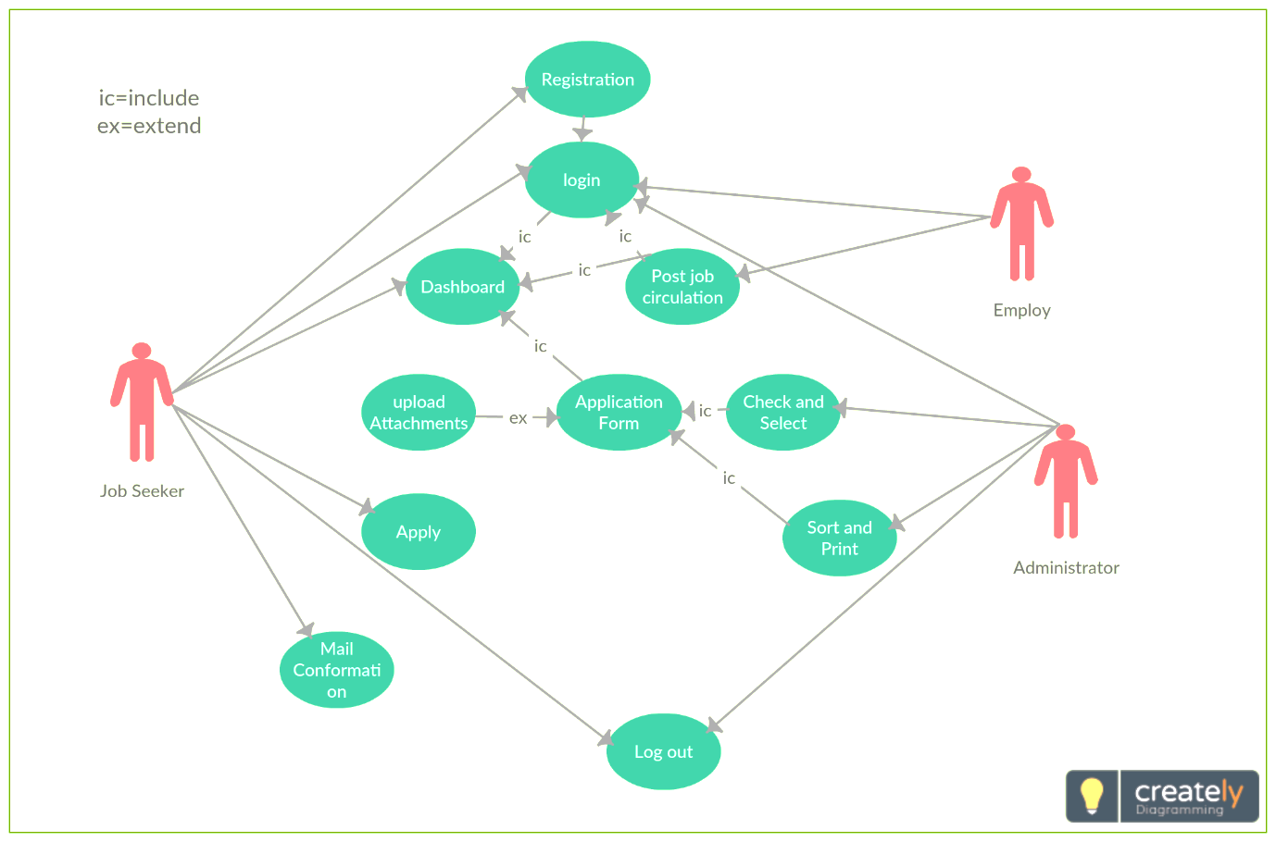

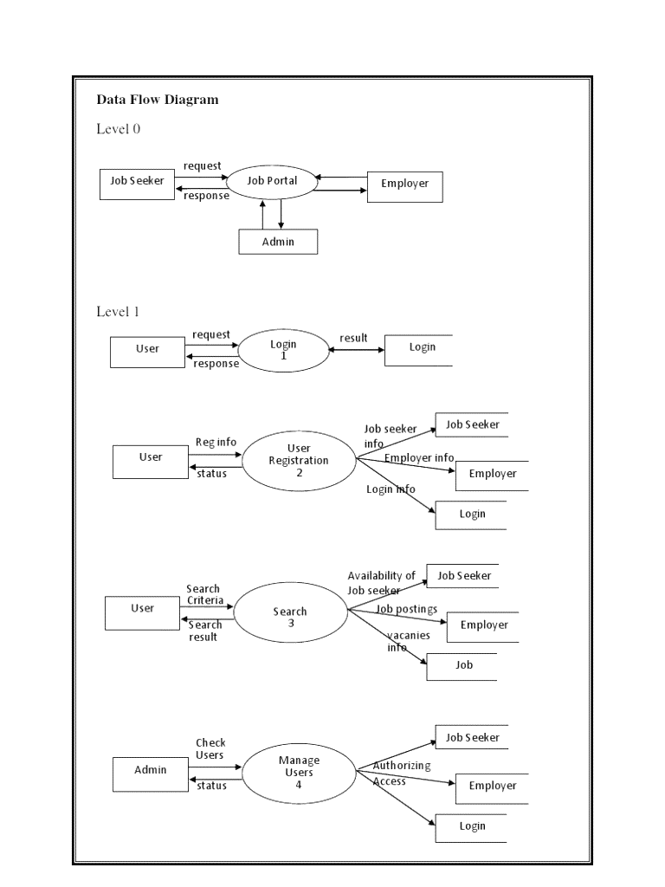

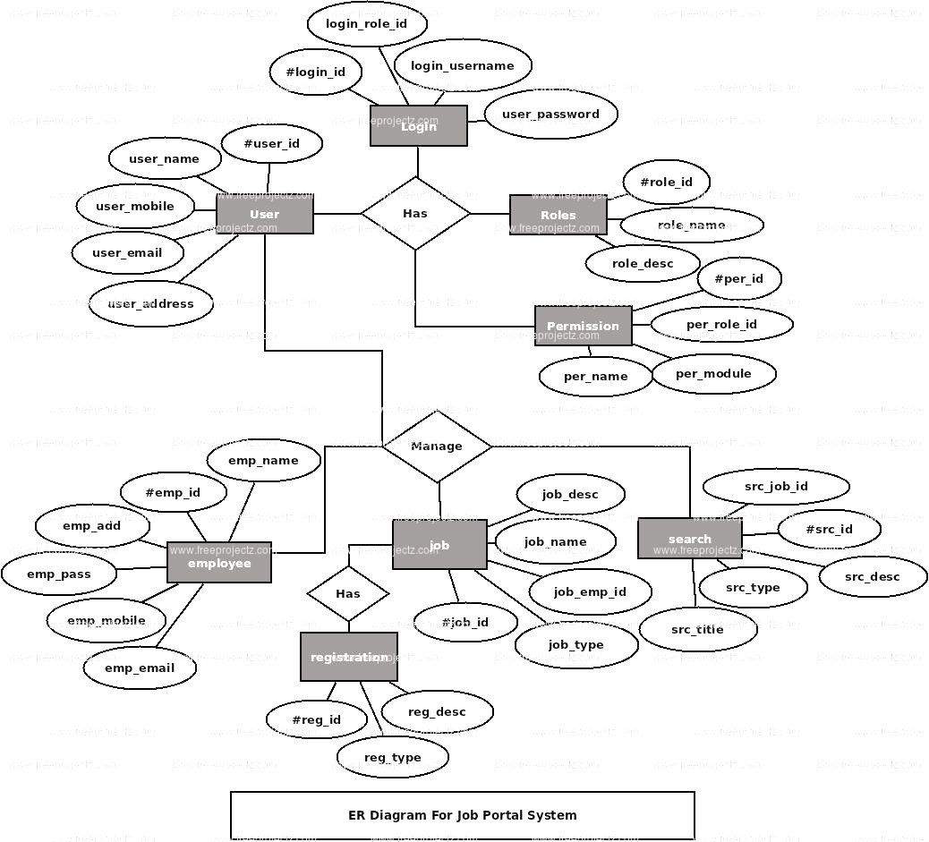

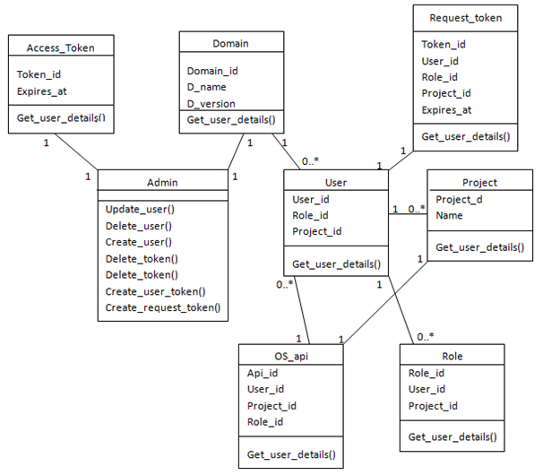

**Technical Requirements:**

**Software**:

VS code studio

MongoDB

Node JS

Insomnia

**Hardware**:

Keyboard

Screen

Printer

Internet

**CONCLUSION:**

Our project is only a humble venture to satisfy the needs to manage their project work. Several user friendly coding have also adopted. This package shall prove to be a powerful package in satisfying all the requirements of the school. The objective of software planning is to provide a frame work that enables the manger to make reasonable estimates made within a limited time frame at the beginning of the software project and should be updated regularly as the project progresses. At the end it is concluded that we have made effort on following points…

* A description of the background and context of the project and its relation to work already done in the area.
* Made statement of the aims and objectives of the project.
* The description of Purpose, Scope, and applicability.
* We define the problem on which we are working in the project.
* We describe the requirement Specifications of the system and the actions that can be done on these things.
* We understand the problem domain and produce a model of the system, which describes operations that can be performed on the system.
* We included features and operations in detail, including screen layouts.
* We designed user interface and security issues related to system.
* Finally the system is implemented and tested according to test cases.